**GOVERNMENT OF TAMILNADU**

**Naan Mudhalvan – Project Based Experiential Learning**

Project Report on

**UNLOCKING INSIGHTS INTO THE GLOBAL AIR TRANSPORTATION NETWORK WITH TABLEAU**

**Submitted by**

**S. Chandralekha (EB74FF172CDE052909D40BD4B1EE527A)**

**N. Anishabanu (FFB72DADD7B0560B8C843B203DB30F2C)**

**V. Kokila (8DD79523A9C6FEA807D4F2431EF9EA7B)**

**P. Varsini (711F057FE57BCCE9A394749476F0100F)**

**(TEAM ID : NM2023TMID07162 )**

**Under the guidance of**

**Dr. M. GAYATHRI M.Sc., Ph.D**

**Guest Lecturer**

**Department of Mathematics**

GOVERNMENT ARTS COLLEGE FOR WOMEN,

(Affiliated to Mother Teresa Women’s University, Kodaikanal)

Reaccredited with “C” Grade by NAAC

NILAKOTTAI-624 208

1 INTRODUCTION

**1.1 Overview**

This Global Air Transportation Network dataset is a comprehensive collection of information on airports, airlines and their routes. It contains information such as names, cities, countries, codes (IATA and ICAO) longitudes, latitudes and altitudes of airports across the world with detailed time zone and daylight saving time data. Additionally, this includes information about airlines including their IDs, name aliases, IATA and ICAO codes, callsigns country of origin and active/inactive status. Similarly, it also covers route details such as airline sources to destination airports along with essential details like codeshare stakeholder if any stops required during this journey along with the type of aircraft being used for that particular journey. This dataset has been compiled through meticulous labour by researchers all over the world to give you a comprehensive detail into air transportation networks from around the globe. It requires your generous donations in order for them to keep updating this data source so please do donate if possible.

**1.2 Purpose**

The business requirement of the Global Air Transportation Network- Airports, Airlines, and Routes dataset is to provide stakeholders in the aviation industry with accurate, up-to-date information on the worldwide air transportation network. The dataset is intended to help stakeholders make informed decisions related to business growth, investment, capacity planning, and infrastructure development. Using data analytics and visualization tools like Tableau, the dataset can be analyzed to identify trends and patterns in the air transportation network, providing valuable insights into the state of the industry. This information can be used to optimize routes, improve operational efficiency, and enhance customer experience.

Ultimately, the business requirement of the dataset is to enable stakeholders in the aviation industry to gain a competitive advantage by making data-driven decisions. By providing a comprehensive collection of data related to the air transportation network, the dataset can help stakeholders stay ahead of the curve in a dynamic and rapidly changing industry.

2 Problem Definition & Design Thinking

Analysing the global air transportation network and creating dashboard, story using tableau.

2.1 Empathy Map  
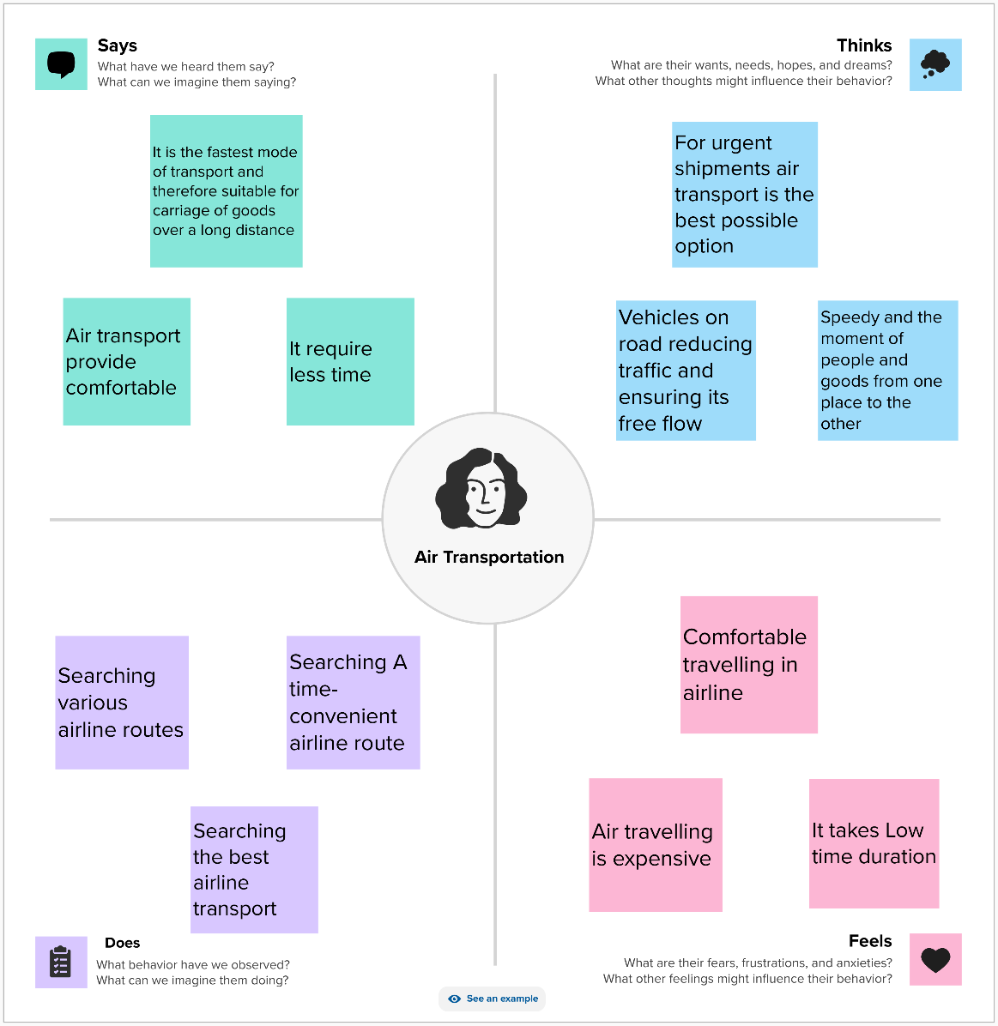

2.2 Ideation & Brainstorming Map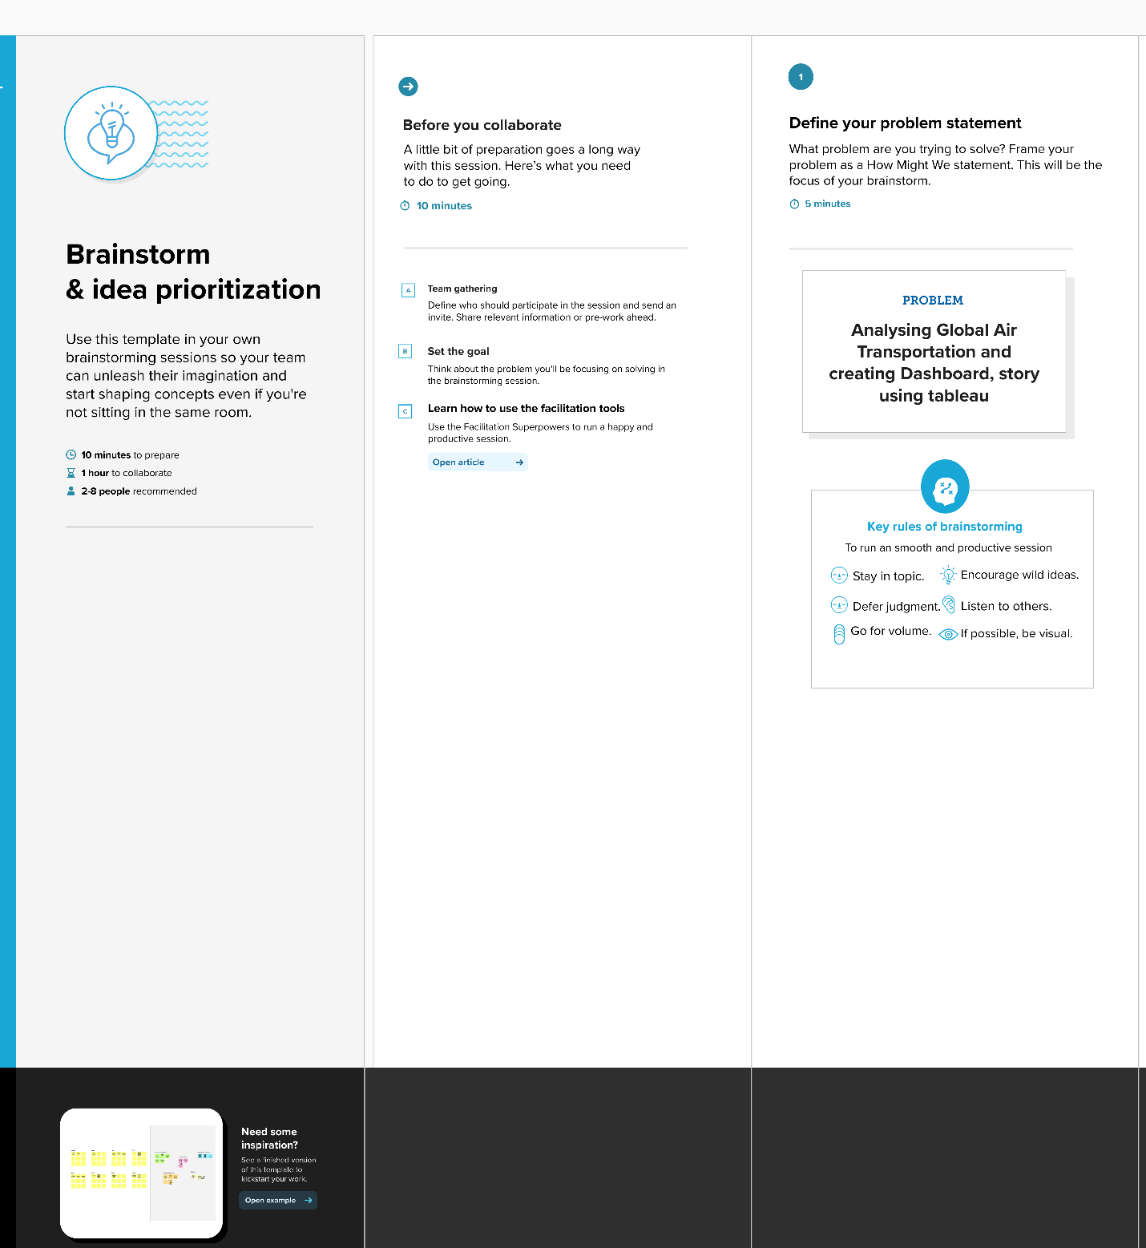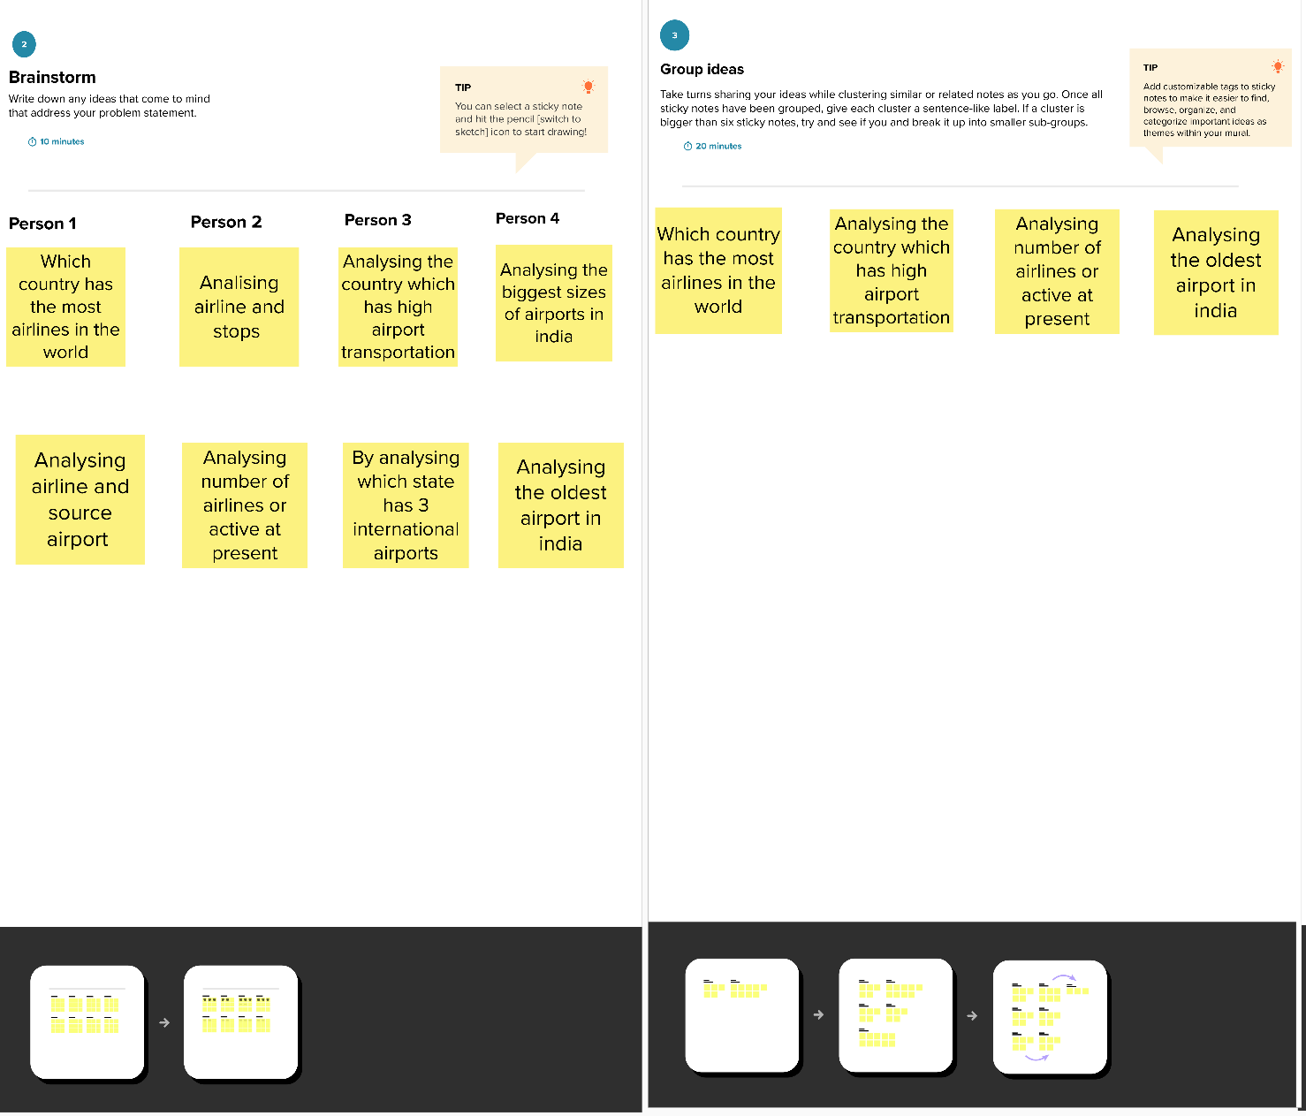

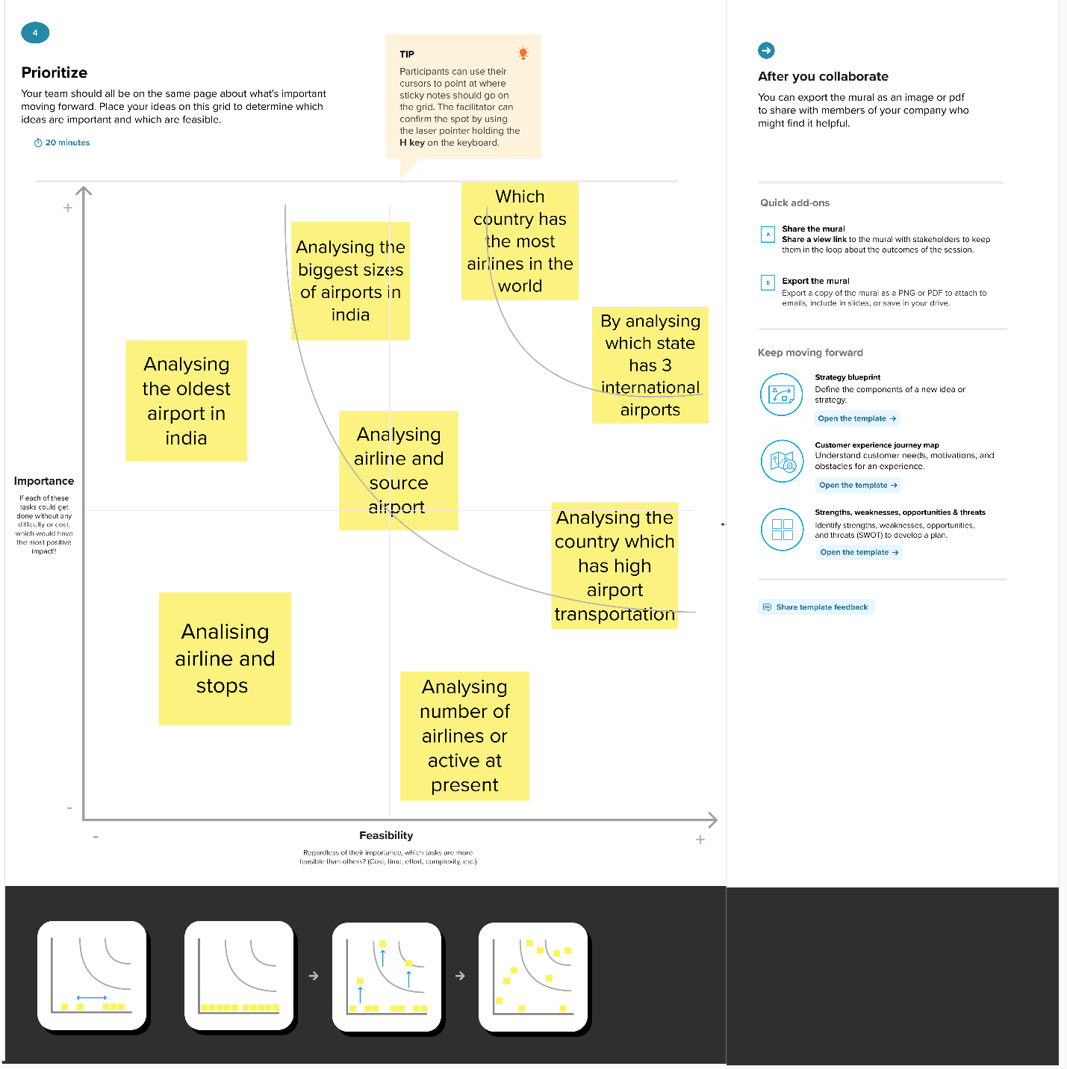

3 RESULT

Activity 1: World Map Showing Details of All Airports Within a Country

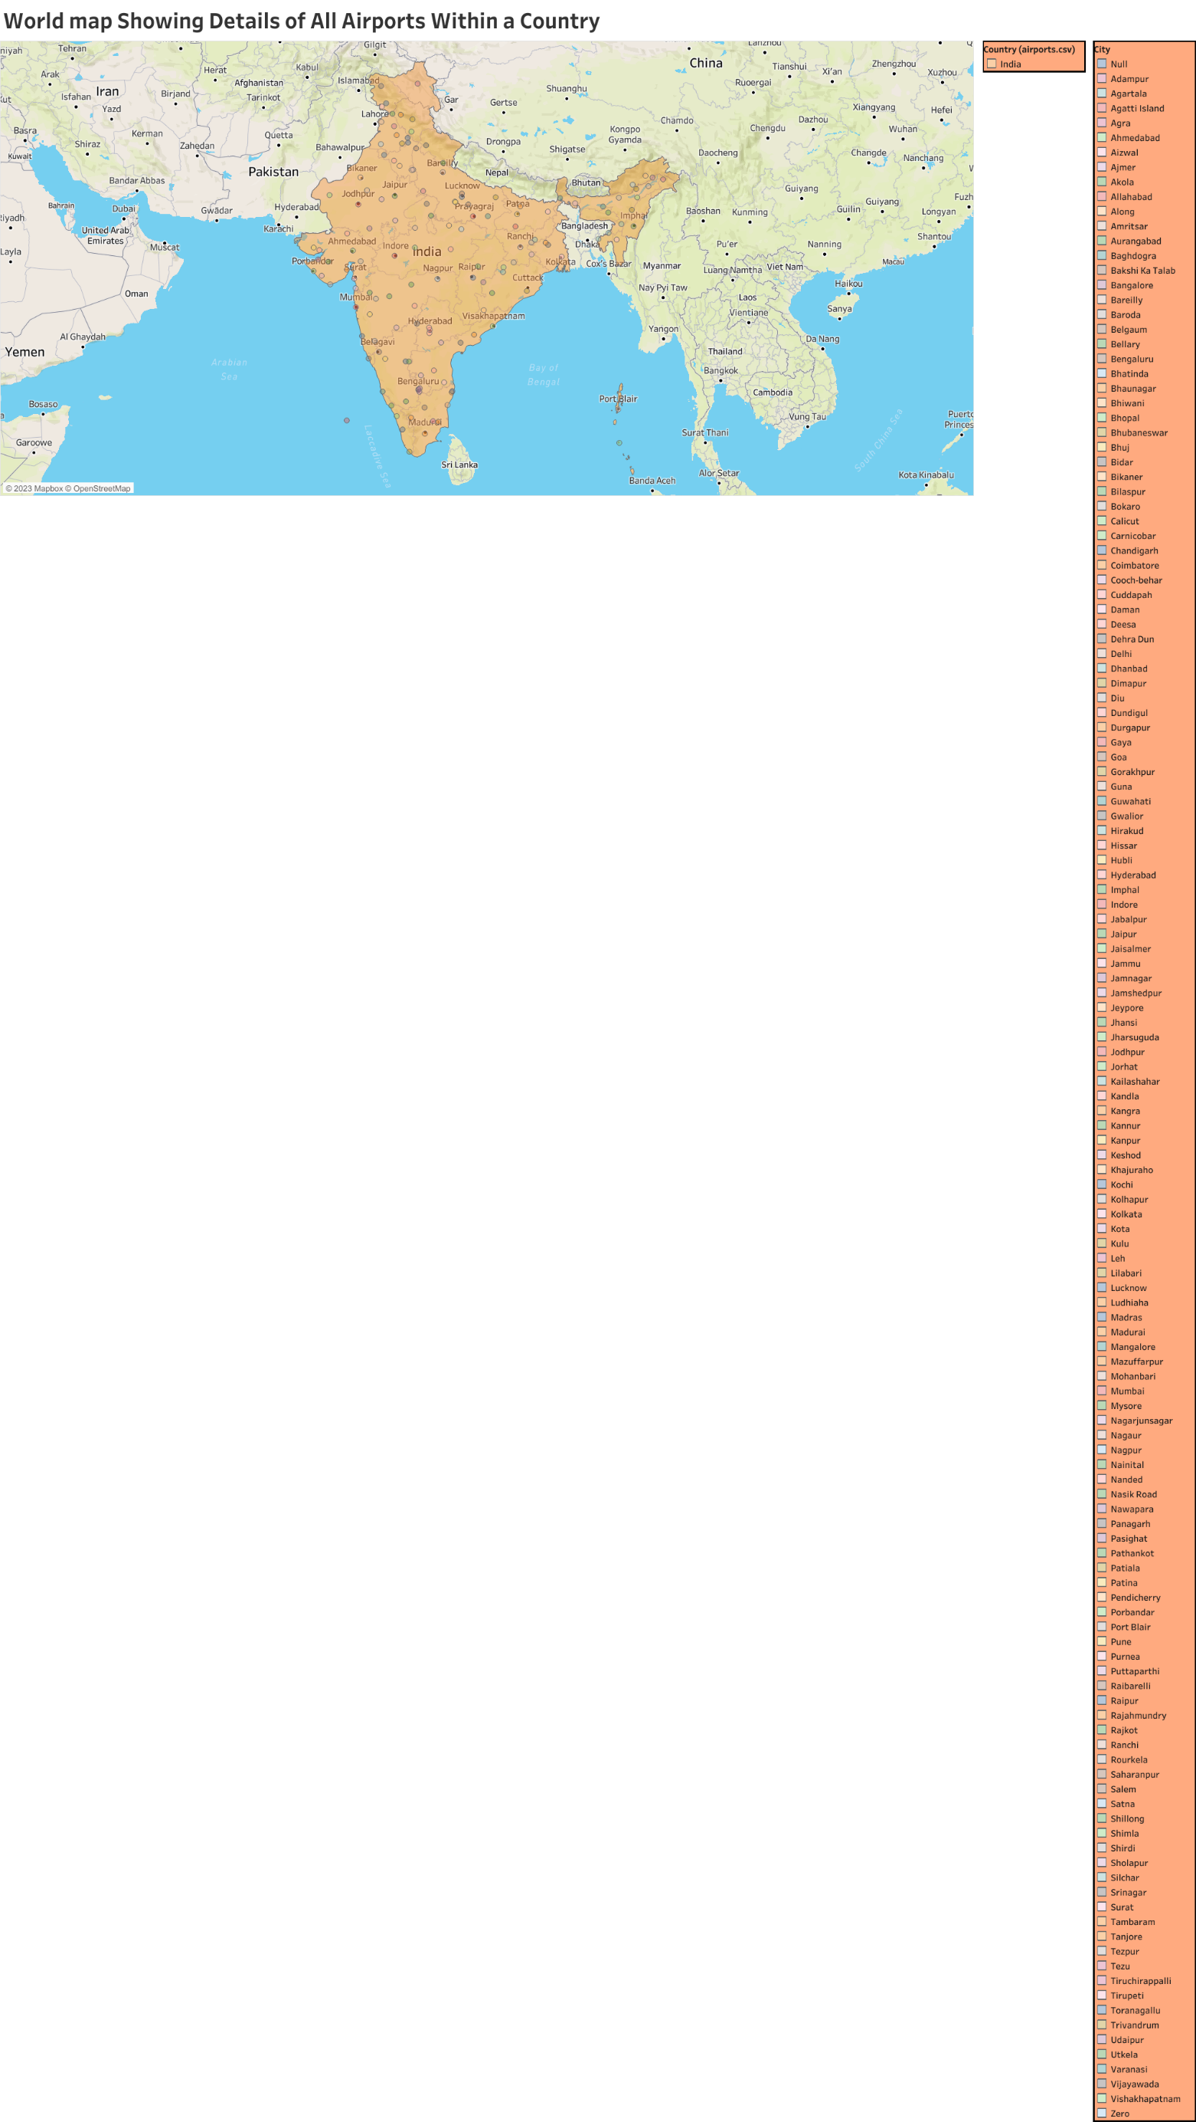

Activity 2 : Number of Airports

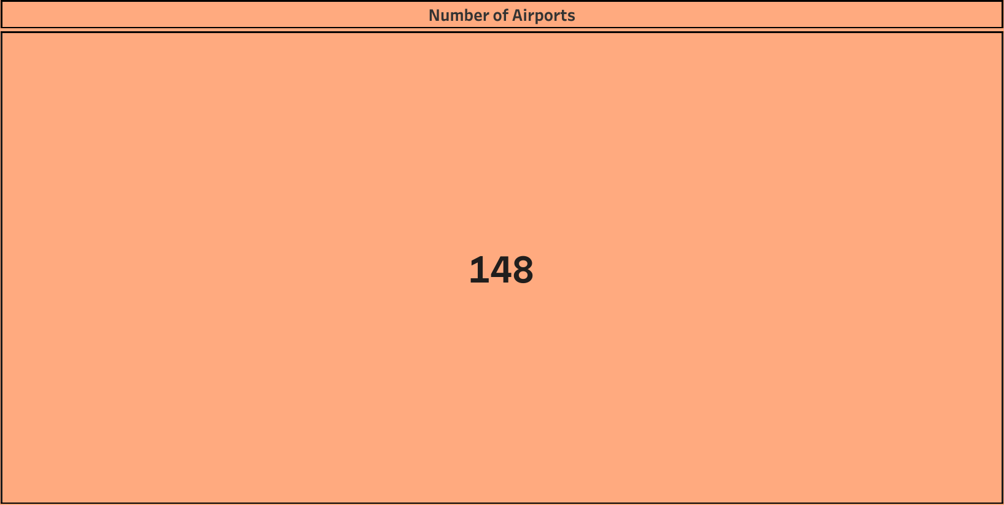

Activity 3 : Number of Airlines

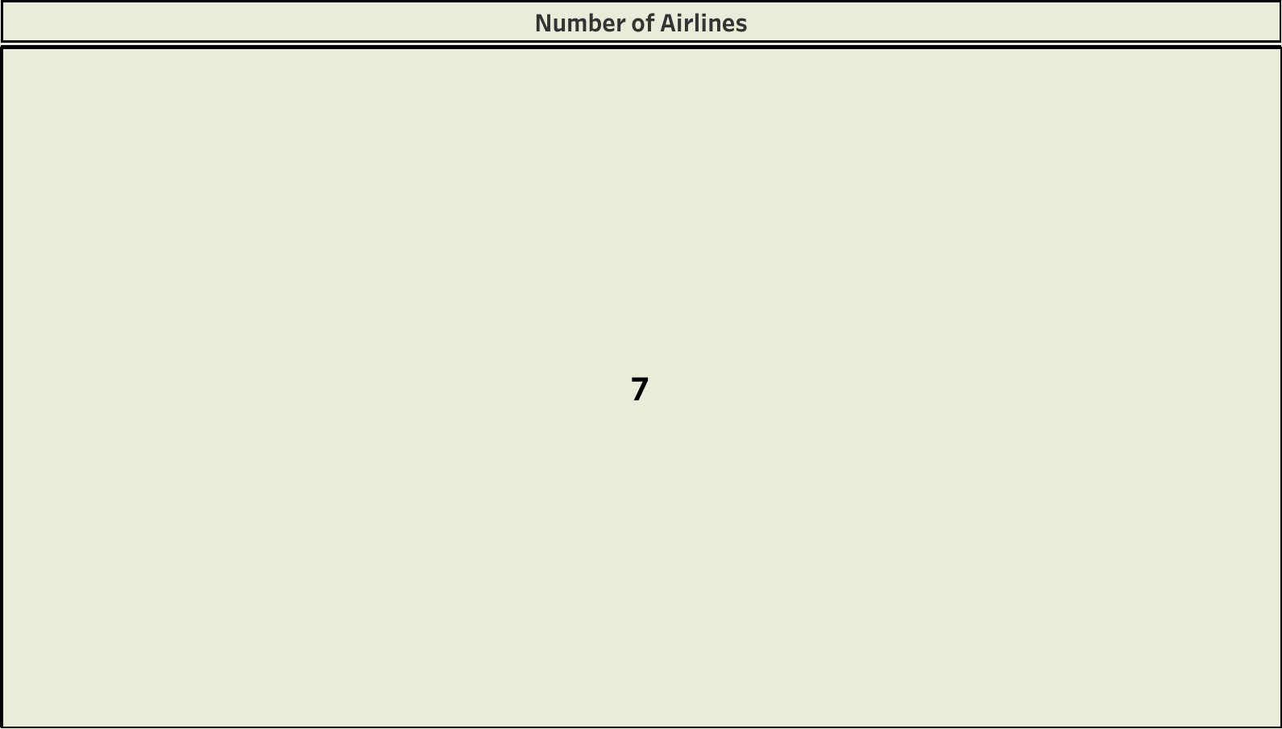

Activity 4 : Airports at Higher Altitude Within a Country

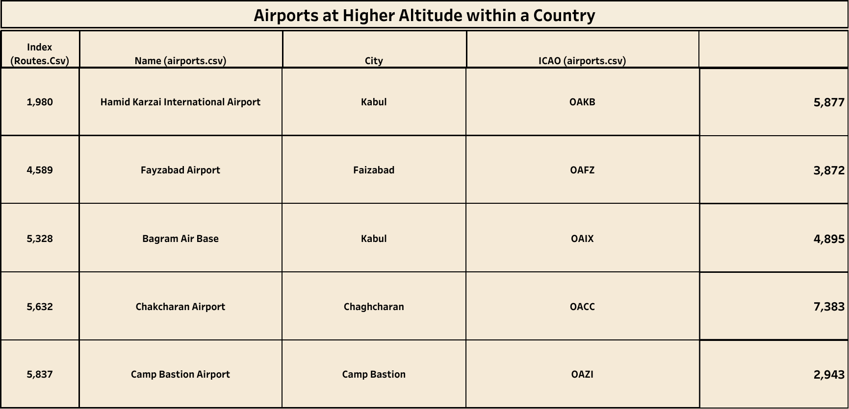

Activity 5 : Airports at Highest Altitude in World

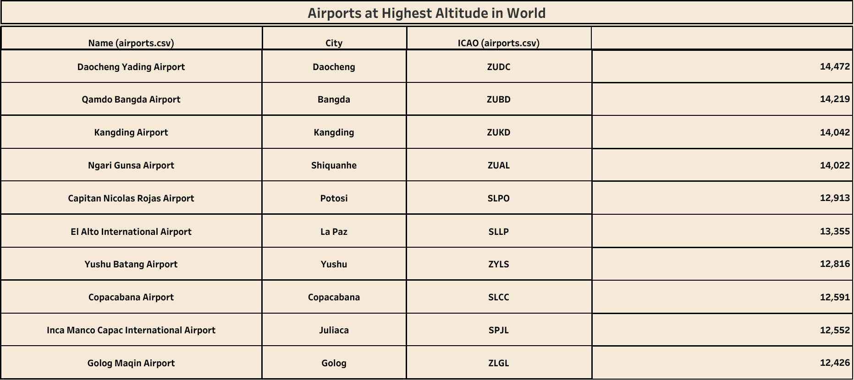

Activity 6 : Airlines Within a Country

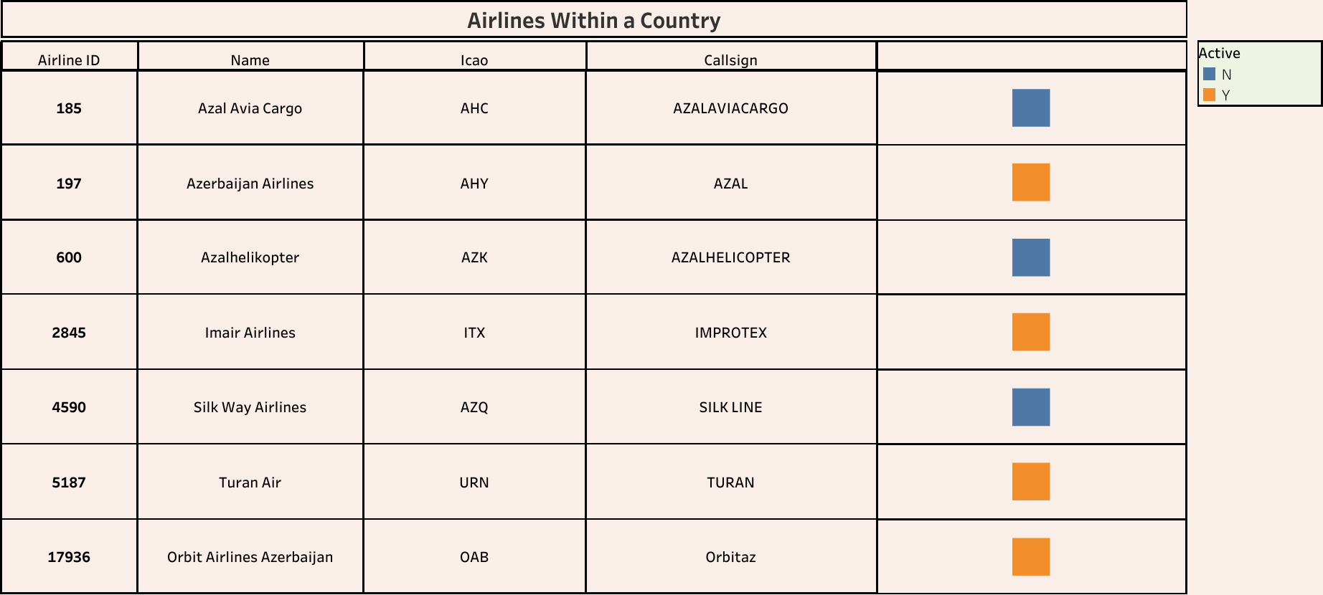Activity 7 : Number of Flights from Airport



Activity 8 : Country With Maximum Number of Airports

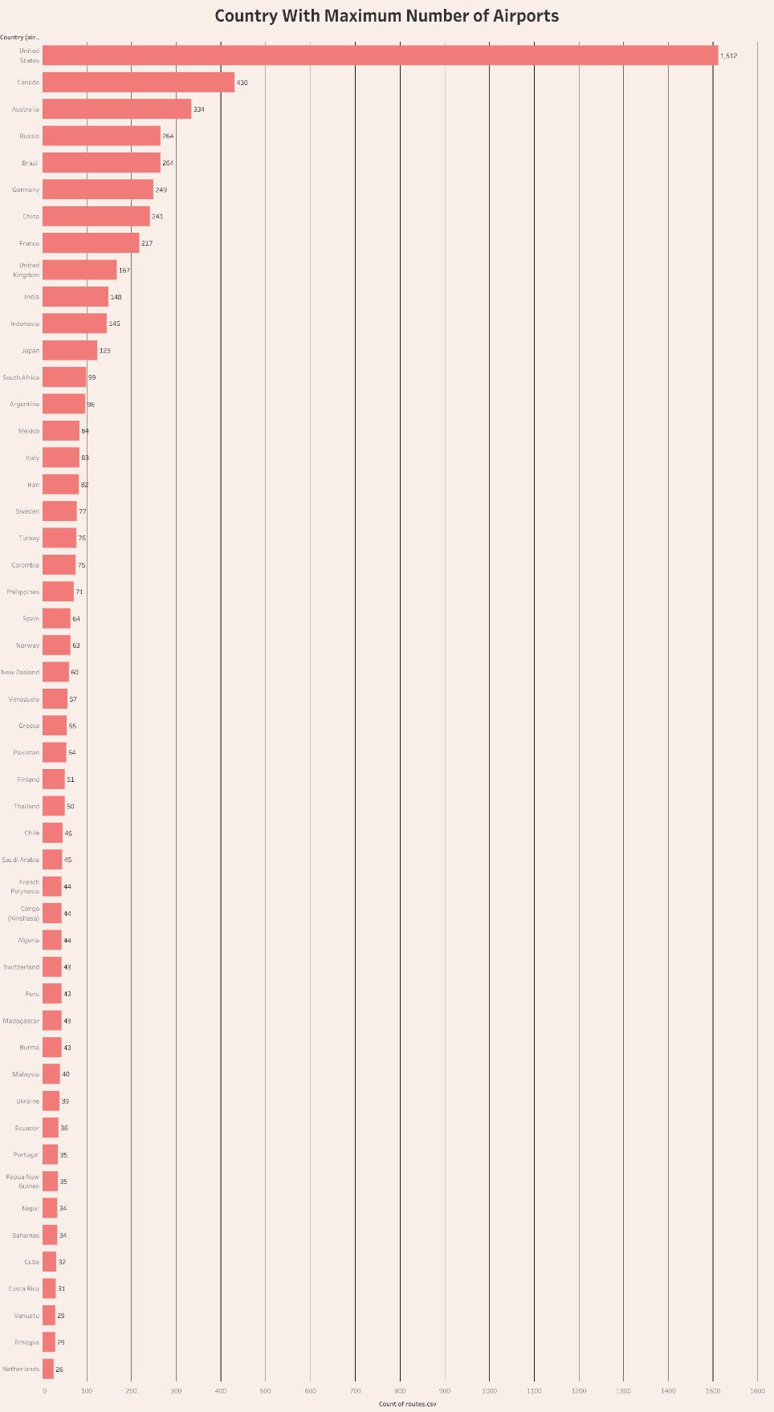

Dashboard 1 : Global Air Transportatrion

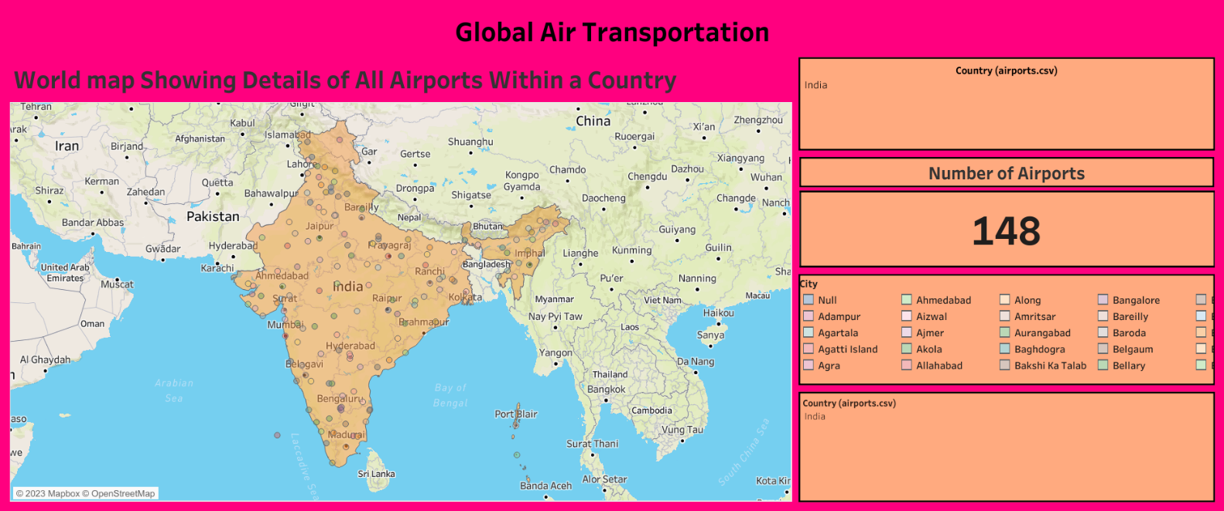

Dashboard 2 : Global Air Transportatrion

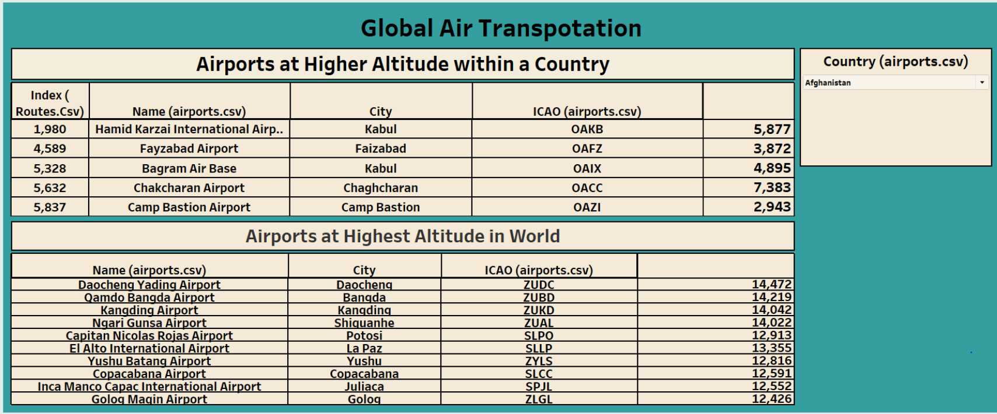

Dashboard 3 : Global Air Transportatrion

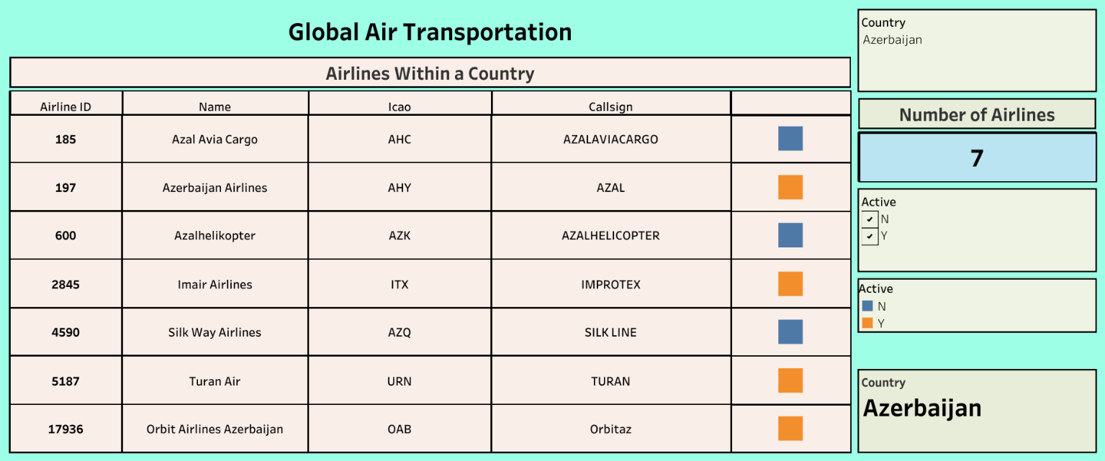

Dashboard 4 : Global Air Transportatrion

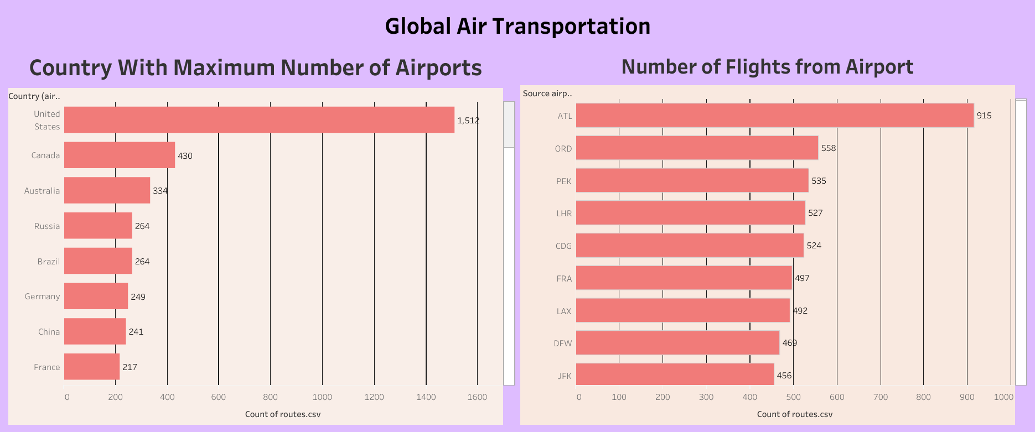

Story Doard:

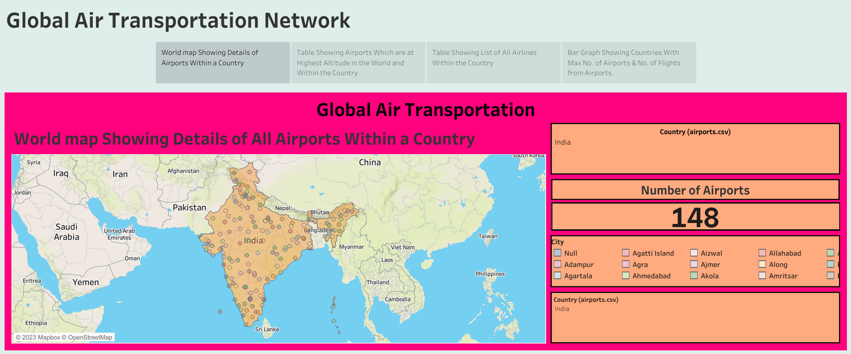

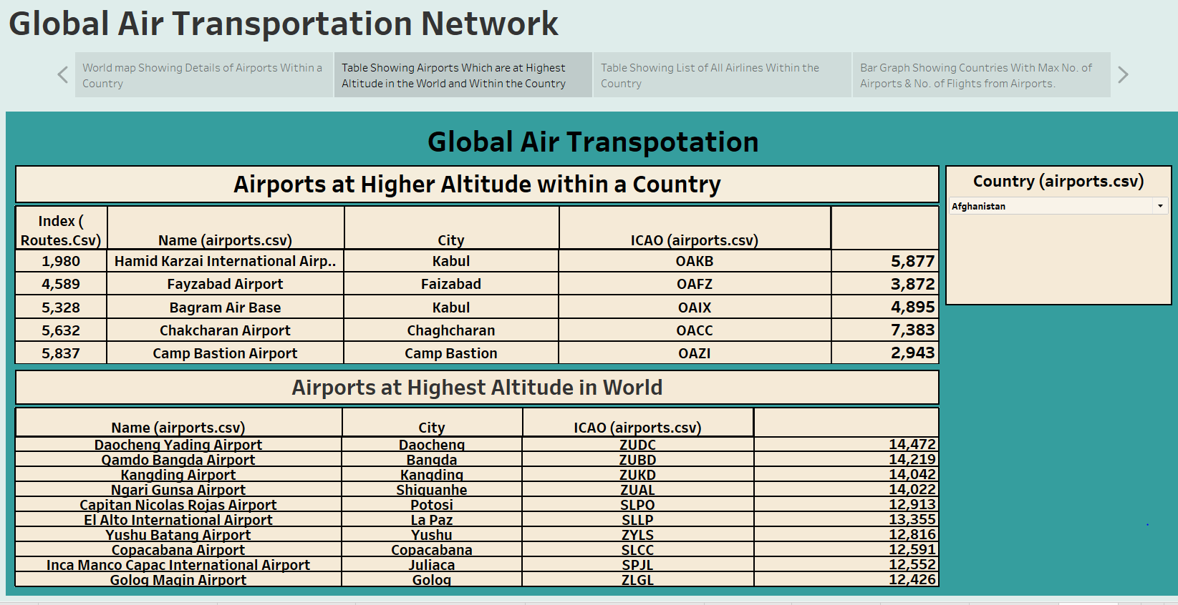

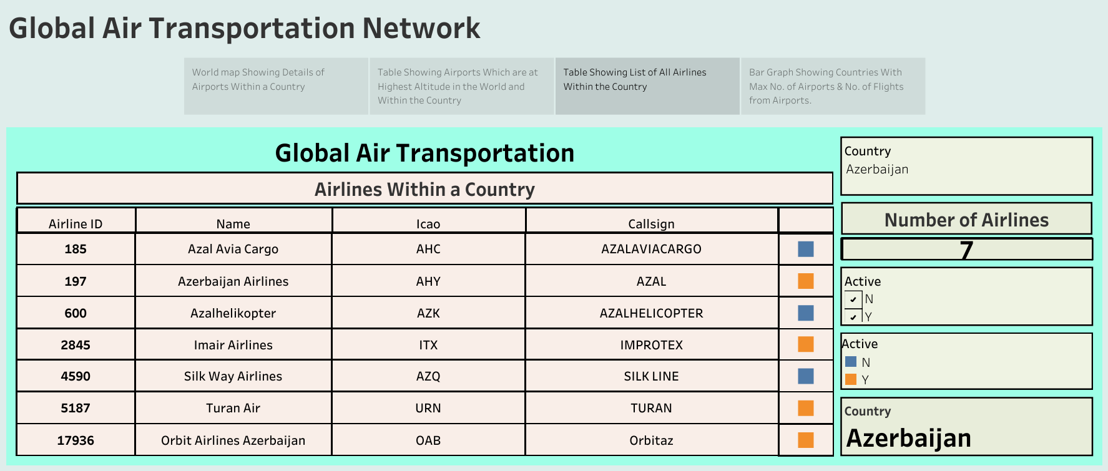

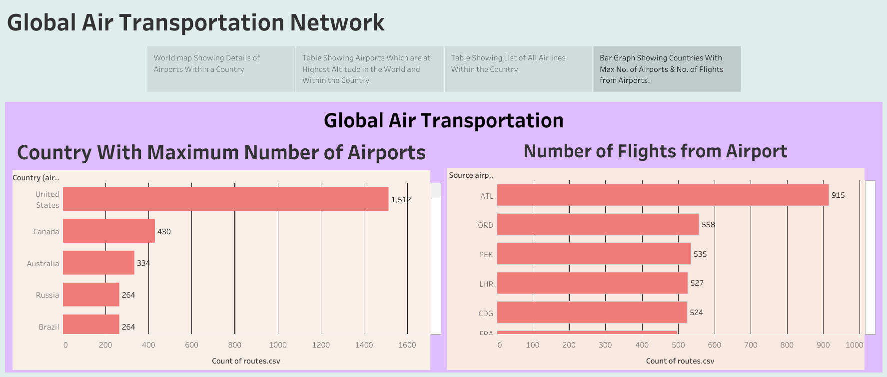

4 ADVANTAGES & DISADVANTAGES

Using Tableau, the dataset is analyzed to identify trends and patterns in the air transportation network, providing valuable insights into the state of the industry. This information can be used to optimize routes, improve operational efficiency, and enhance customer experience

5 APPLICATIONS

Socially, the dataset can contribute to the development of air transportation networks that are more efficient, safe, and environmentally sustainable. By providing stakeholders with a comprehensive understanding of the air transportation network, the dataset can help to optimize routes and reduce congestion in the air, leading to improved air quality and reduced carbon emissions. This can contribute to the overall well-being of communities around the world, by making air travel more accessible, affordable, and eco-friendly.

From a business perspective, the dataset can have a significant impact on the aviation industry. By enabling stakeholders to make data-driven decisions, the dataset can help airlines, airport authorities, tourism boards, and government agencies to identify new business opportunities, optimize capacity planning, and streamline operations. This can lead to increased profitability and competitiveness, as well as improved customer experience. Moreover, the dataset can be used by investors to identify promising sectors and geographic areas for investment in the aviation industry

6 CONCLUSION

Using the information such as names, cities, countries, codes (IATA and ICAO) longitudes, latitudes and altitudes of airports across the world with detailed time zone and daylight saving time data, we have created the visualization which shows the details of all airports within each country, the number of airports in a country, airports with high altitude. From these one can optimize routes, improve operational efficiency, and enhance customer experience

7 FUTURE SCOPEIn future, we can extend to analyze the optimizing routes wise cost and time by collecting such information